**Ayesha Zubair**

**52916**

**Computer Architecture Lab**

**Task 2**

**Task 1 (AND OR Combinational)**

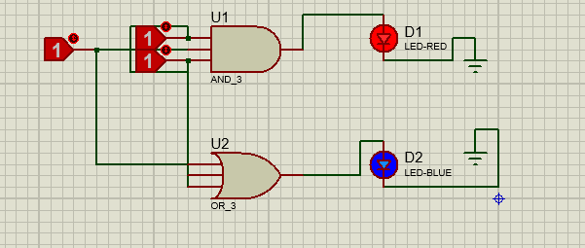

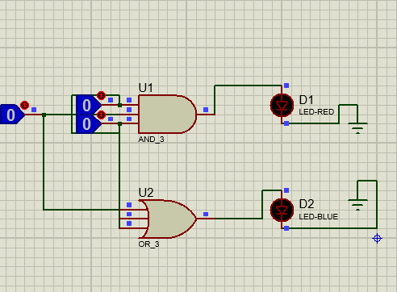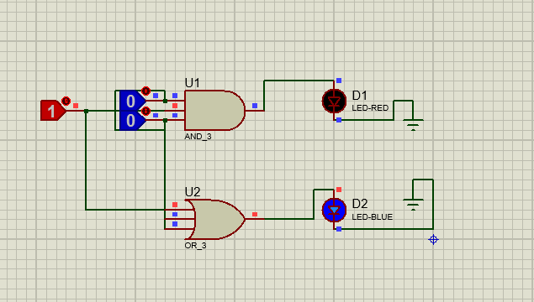

**Task 2 (NAND XOR Combinational)**

